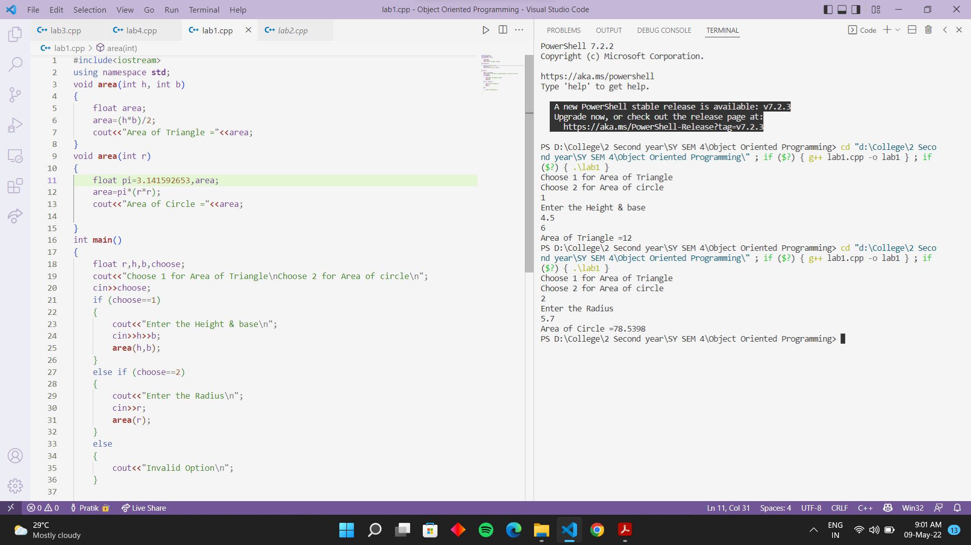

#include<iostream>

#include<stdio.h>

#include<string.h>

using namespace **std**;

class **bank**

{

        int account_no;

        char num[100], acctype[100];

        float bal;

   public:

**bank**(int acc_no, char *name, char *acc_type, float balance) *//Parameterized Constructor*

        {

                account_no=acc_no;

**strcpy**(num, name);

**strcpy**(acctype, acc_type);

                bal=balance;

        }

        void **deposit**();

        void **withdraw**();

        void **display**();

};

void **bank**::**deposit**() *//depositing an amount*

{

        int deamt1;

        cout**<<**"\n Enter Deposit Amount = ";

        cin**>>**deamt1;

        bal+=deamt1;

}

void **bank**::**withdraw**() *//withdrawing an amount*

{

        int withdrawamt;

        cout**<<**"\n Enter Withdraw Amount = ";

        cin**>>**withdrawamt;

        if(withdrawamt>bal){

                cout**<<**"\n Cannot Withdraw Amount";

        }

        bal-=withdrawamt;

}

void **bank**::**display**() *//displaying the details*

{

        cout**<<**"\n ----------------------";

        cout**<<**"\n Accout No. : "**<<**account_no;

        cout**<<**"\n Name : "**<<**num;

        cout**<<**"\n Account Type : "**<<**acctype;

        cout**<<**"\n Balance : "**<<**bal;

}

int **main**()

{

        int acc_no;

        char name[100], acc_type[100];

        float balance;

        cout**<<**"\n Enter Details: \n";

        cout**<<**"-----------------------";

        cout**<<**"\n Accout No. ";

        cin**>>**acc_no;

        cout**<<**"\n Name : ";

        cin**>>**name;

        cout**<<**"\n Account Type : ";

        cin**>>**acc_type;

        cout**<<**"\n Balance : ";

        cin**>>**balance;

**bank** **b1**(acc_no, name, acc_type, balance); *//object is created*

        b1.**deposit**(); *//*

        b1.**withdraw**(); *// calling member functions*

        b1.**display**();

        return 0;

}

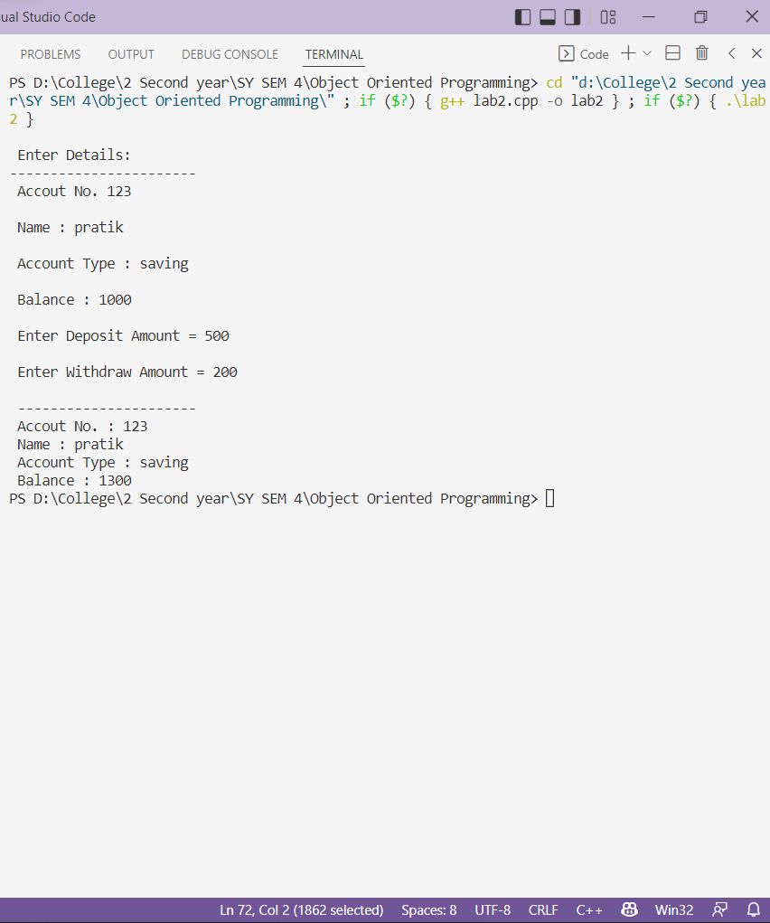

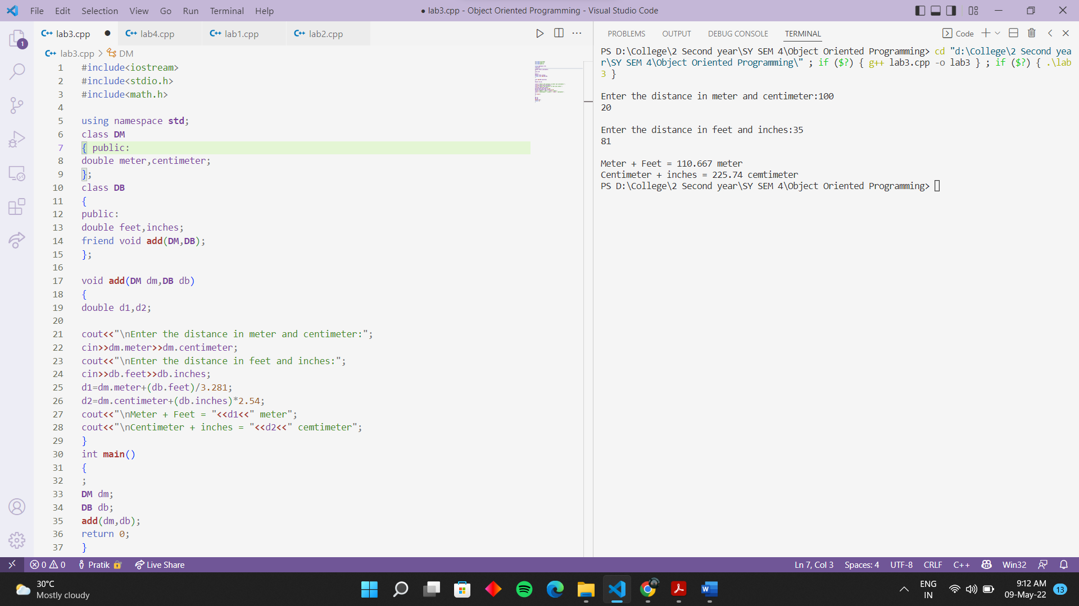

#include <iostream>

#include <conio.h>

#include <process.h>

using namespace **std**;

class **mat**

{

    int a[20][20], b[20][20],c[20][20];

    int i, j, k, p, q, x, y;

public:

    void **addition**(void);

    void **substraction**(void);

    void **multiplication**(void);

};

void **mat**::**addition**()

{

    cout **<<** "\nENTER THE DIMENSION OF MATRIX A::\t";

    cin **>>** x **>>** y;

    cout **<<** "\nENTER THE DIMENSION OF MATRIX b::\t";

    cin **>>** p **>>** q;

    if ((x == p) && (y == q))

    {

        cout **<<** "\nENTER THE" **<<** x **<<** "*" **<<** y **<<** "ELEMENTS OF MATRIX A::\n";

        for (i = 0; i < x; i++)

        {

            for (j = 0; j < y; j++)

                cin **>>** a[i][j];

        }

        cout **<<** "\nENTER THE" **<<** p **<<** "*" **<<** q **<<** "ELEMENTS OF MATRIX B::\n";

        for (i = 0; i < p; i++)

        {

            for (j = 0; j < q; j++)

                cin **>>** b[i][j];

        }

        cout **<<** "\nSUM OF MATRIX A & B::\n";

        for (i = 0; i < x; i++)

        {

            for (j = 0; j < y; j++)

                c[i][j] = a[i][j] + b[i][j];

        }

        for (i = 0; i < x; i++)

        {

            for (j = 0; j < y; j++)

                cout **<<** c[i][j] **<<** "\t";

            cout **<<** "\n";

        }

    }

    else

        cout **<<** "\nADDITION IS NOT POSSIBLE::";

}

void **mat**::**substraction**()

{

    cout **<<** "\nENTER THE DIMENSION OF MATRIX A::\t";

    cin **>>** x **>>** y;

    cout **<<** "\nENTER THE DIMENSION OF MATRIX b::\t";

    cin **>>** p **>>** q;

    if ((x == p) && (y == q))

    {

        cout **<<** "\nENTER THE" **<<** x **<<** "*" **<<** y **<<** "ELEMENTS OF MATRIX A::\n";

        for (i = 0; i < x; i++)

        {

            for (j = 0; j < y; j++)

                cin **>>** a[i][j];

        }

        cout **<<** "\nENTER THE" **<<** p **<<** "*" **<<** q **<<** "ELEMENTS OF MATRIX B::\n";

        for (i = 0; i < p; i++)

        {

            for (j = 0; j < q; j++)

                cin **>>** b[i][j];

        }

        cout **<<** "\nDIFFERENCE OF THE MATRIX A & B::\n";

        for (i = 0; i < x; i++)

        {

            for (j = 0; j < y; j++)

                c[i][j] = a[i][j] - b[i][j];

        }

        for (i = 0; i < x; i++)

        {

            for (j = 0; j < y; j++)

                cout **<<** c[i][j] **<<** "\t";

            cout **<<** "\n";

        }

    }

    else

        cout **<<** "\nSUBSTRACTION IS NOT POSSIBLE::";

}

void **mat**::**multiplication**()

{

    cout **<<** "\nENTER THE DIMENSION OF MATRIX A::\t";

    cin **>>** x **>>** y;

    cout **<<** "\nENTER THE DIMENSION OF MATRIX b::\t";

    cin **>>** p **>>** q;

    if (y == q)

    {

        cout **<<** "\nENTER THE" **<<** x **<<** "*" **<<** y **<<** "ELEMENTS OF MATRIX A::\n";

        for (i = 0; i < x; i++)

        {

            for (j = 0; j < y; j++)

                cin **>>** a[i][j];

        }

        cout **<<** "\nENTER THE" **<<** p **<<** "*" **<<** q **<<** "ELEMENTS OF MATRIX B::\n";

        for (i = 0; i < p; i++)

        {

            for (j = 0; j < q; j++)

                cin **>>** b[i][j];

        }

        cout **<<** "\nPROCUCT OF THE MATRIX A & B::\n";

        for (i = 0; i < x; i++)

        {

            for (j = 0; j < q; j++)

            {

                c[i][j] = 0;

                for (k = 0; k < y; k++)

                    c[i][j] = a[i][k] * b[k][i] + c[i][j];

            }

        }

        for (i = 0; i < x; i++)

        {

            for (j = 0; j < q; j++)

                cout **<<** c[i][j] **<<** "\t";

            cout **<<** "\n";

        }

    }

    else

        cout **<<** "\nMULTIPLICATION IS NOT POSSIBLE::";

}

int **main**()

{

    int c;

    char ch;

**mat** M;

    do

    {

        cout **<<** "\t\tMATRIX OPERATION\n\n";

        cout **<<** "\n1.ADDITION\n2.SUBSTRACTION\n3.MULTIPLICATION\n";

        cout **<<** "\nENTER YOUR CHOICE::\t";

        cin **>>** c;

        switch (c)

        {

        case 1:

            M.**addition**();

                break;

        case 2:

            M.**substraction**();

                break;

        case 3:

            M.**multiplication**();

                break;

            default:

            cout **<<** "Wrong Choice";

        }

        cout **<<** "\nDoyou want to continue[y/n]::\t";

        cin **>>** ch;

    }

    while (ch == 'y', ch == 'Y');

    return 0;

}

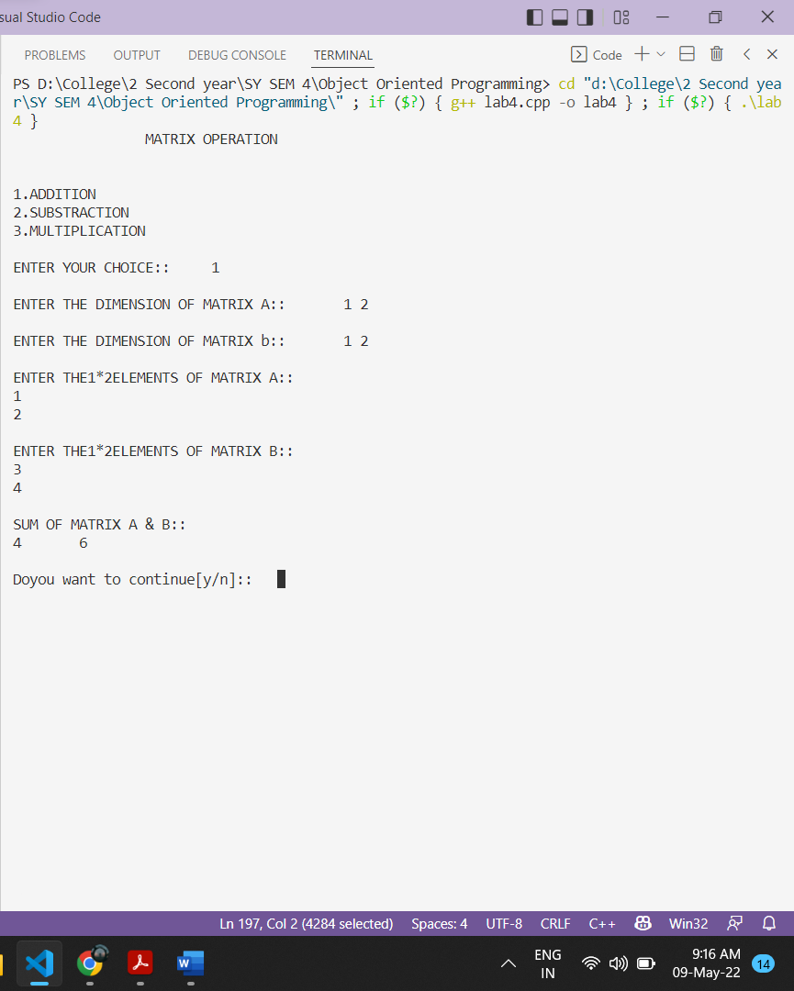

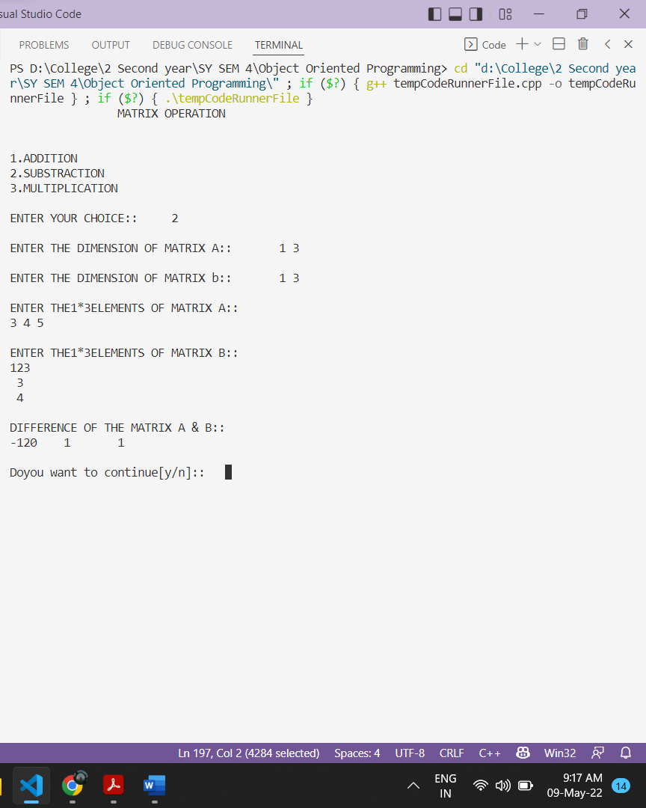

#include <iostream>

using namespace **std**;

class **stu**

{

private:

    char name[20], add[20];

    int roll, zip;

public:

**stu**(); *// Constructor*

**~stu**(); *// Destructor*

    void **read**();

    void **disp**();

};

**stu** ::**stu**()

{

    cout **<<** "\nThis is Student Details constructor called..........." **<<** **endl**;

}

void **stu** ::**read**()

{

    cout **<<** "\nEnter the student Name :: ";

    cin **>>** name;

    cout **<<** "\nEnter the student roll no :: ";

    cin **>>** roll;

    cout **<<** "\nEnter the student address :: ";

    cin **>>** add;

    cout **<<** "\nEnter the Zipcode :: ";

    cin **>>** zip;

}

void **stu** ::**disp**()

{

    cout **<<** "\nThe Entered Student Details are shown below ::---------- \n";

    cout **<<** "\nStudent Name :: " **<<** name **<<** **endl**;

    cout **<<** "\nRoll no   is :: " **<<** roll **<<** **endl**;

    cout **<<** "\nAddress is :: " **<<** add **<<** **endl**;

    cout **<<** "\nZipcode is :: " **<<** zip;

}

**stu** ::**~stu**()

{

    cout **<<** "\n\nStudent Detail is Closed.............\n";

}

int **main**()

{

**stu** s;

    s.**read**();

    s.**disp**();

    return 0;

}

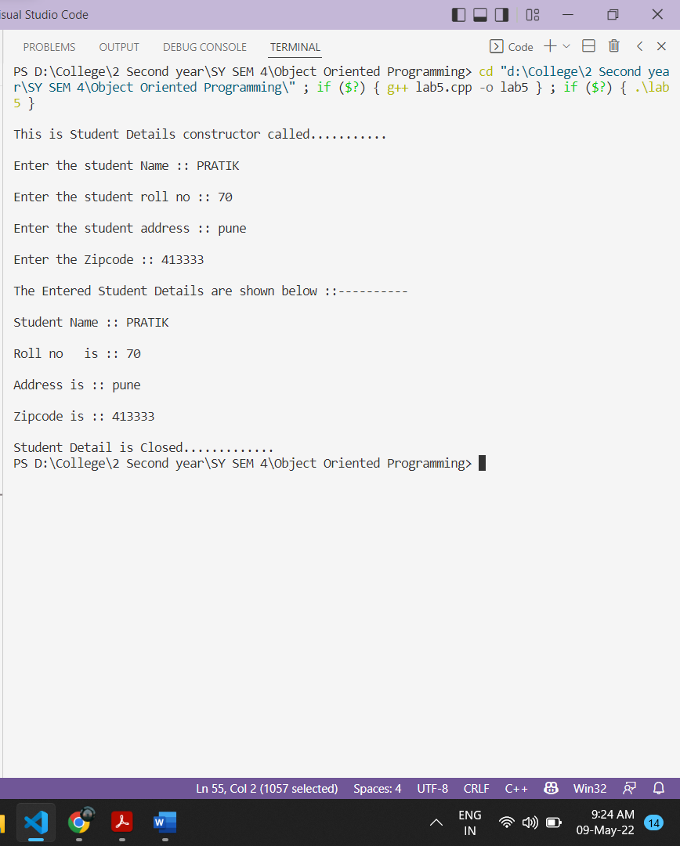

#include <iostream>

#include <conio.h>

#include <string.h>

using namespace **std**;

class **person**

{

protected:

    char name[20];

    int code;

public:

    void **get_per**(int c, char *s)

    {

        code = c;

**strcpy**(name, s);

    }

    void **put_per**()

    {

        cout **<<** "\nCode : " **<<** code;

        cout **<<** "\nName : " **<<** name;

    }

};

class **account** : public virtual **person**

{

protected:

    float pay;

public:

    void **get_pay**(float p)

    {

        pay = p;

    }

    void **put_pay**()

    {

        cout **<<** "\nPay amount : " **<<** pay;

    }

};

class **admin** : public virtual **person**

{

protected:

    int exp;

public:

    void **get_exp**(int e)

    {

        exp = e;

    }

    void **put_exp**()

    {

        cout **<<** "\nExperiance : " **<<** exp;

    }

};

class **master** : public **account**, public **admin**

{

*// private:*

*// float pay;*

*// int code,exp;*

*// char name;*

public:

    void **display**()

    {

**put_per**();

**put_pay**();

**put_exp**();

    }

};

int **main**()

{

**master** p1;

    p1.**get_per**(111, "Piyush");

    p1.**get_pay**(501.50);

    p1.**get_exp**(2);

    p1.**display**();

    return 0;

}

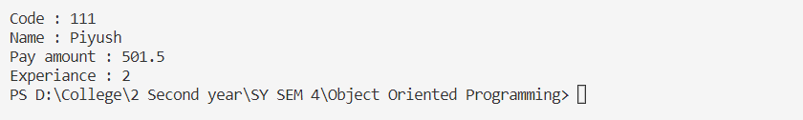

#include <iostream>

#include<string>

using namespace **std**;

class **media**

{

    protected:

**string** title;

    float price;

    public:

**media**()

    {

        title**=**" ";

        price=0.0;

        }

**media**(**string** t,float P)

        {

            title**=**t;

            price=P;

            }

    };

    class **book** : public **media**

    {

        int P_count;

        public:

**book**()

        {

            P_count=0;

        }

**book**(**string** t,float P,int pc):**media**(t,P)

        {

            P_count=pc;

        }

     void **display**()

     {

          cout**<<**"title :"**<<**title**<<endl**;

                cout**<<**"Price: "**<<**price**<<endl**;

          cout**<<**"Pagecount :"**<<**P_count**<<endl**;

        }

    };

 class **CD** : public **media**

    {

        float time;

        public:

**CD**()

        {

            time=0.0;

        }

**CD**(**string** t,float p,float tim):**media**(t,p)

        {

            time=tim;

        }

     void **display**()

     {

         cout**<<**"title :"**<<**title**<<endl**;

                cout**<<**"Price: "**<<**price**<<endl**;

          cout**<<**"time in minutes :"**<<**time**<<endl**;

        }

    };

int **main**()

{

    cout**<<endl<<**"Book information"**<<endl**;

**book** **Bo**("programming in java",1000,500);

    Bo.**display**();

    cout**<<endl<<**"video information"**<<endl**;

**CD** **cd**("programming in c++",100,125);

    cd.**display**();

    return 0;

        }

